Chapter 11 – Foundations of Chemistry

Lesson 1 – Classifying Matter
Matter – is anything that has mass and takes up space.
Everything you see (and somethings you can’t see) is made up of matter.
Ex: Air is matter but you cannot see it.

Atom – small particle of element that has all the properties of the element.
- center of atom is the nucleus
- nucleus is made up of protons (+ charge) and neutrons (NO charge).
- electrons – have a (-) charge and are found moving around the nucleus in the electron cloud.

2 main Classifications of Matter:
- Substances
- Mixtures

- Substance – matter with a composition that is always the same.
There are 2 types of Substances:
- Elements
- Compounds
Elements – a substance that consist of just one type of atom.
There are 118 known elements – found on the Periodic Table of Elements.
Each atom of an element contains a different number of protons. (atomic #)
Example: Aluminum has 13 protons = atomic # 13

- Most elements exist as a single atom:
Examples: Aluminum Atom
Al

Iron Atom
Fe

- Some elements exist in groups of atoms
Example: Oxygen O₂ 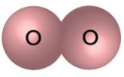
Oxygen molecule – it is an element because it is only made up of one type of atom.

Compounds – a type of substance containing atoms of two or more different elements chemically bonded together.
Examples:
H₂O (Water) 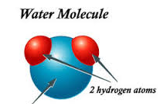 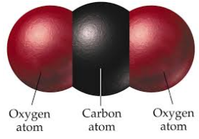 CO₂ – Carbon Dioxide

In a compound the atoms are always combined the same way = substance.
Chemical Formula – shows how the atoms combine. A shorthand way of writing a compounds name.
CO₂ Small 2 is called a subscript and tells us the number of atoms for that element.
Carbon Atoms (1)
Oxygen Atoms (2)

Properties of Compounds
A compound often has different properties from the individual elements that make it up.
Example: Carbon is a black solid.
Oxygen is a clear gas that is flammable.
These two elements combine to produce CO₂ which is a gas used to put out fires.

Mixtures
Mixture is matter that can vary in composition. Two or more substances that are physically blended.
Can separate mixtures:
- Sorting chromatography
- Filtering evaporation

2 Types of Mixtures:
- Heterogeneous Mixture
- Homogeneous Mixture

- Heterogeneous Mixture
– type of mixture in which the individual substances are not evenly mixed.
- 2 samples of the same mixture can have different amount of substances.

Example: A handful of trail mix
One handful will not have the same number of peanuts, raisins, M&M’s as the next.

- Homogeneous Mixture
- type of mixture in which the individual substances are evenly mixed.
- particles of individual substances are so small and well-mixed, that they are not visible.
Example: Ocean Water, Lemonade

A homogenous mixture can also be known as a solution (when one substance dissolves in another).

Solvent – substance that does the dissolving (ie: water)
Solvent – substance that dissolves (ie: lemonade crystals)

2 samples of the same solution will have the same amount of each substance.

